Pablo Picasso Biography
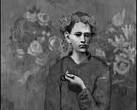
Garcon a la Pipe

Birthday: October 25, 1881
Birthplace: Malaga, Spain

Pablo Picasso's Colorful Childhood
Picasso was the son of a Spanish art teacher. He painted and drew from an early age (he even painted his sister with egg yolks) and when he was 14 he applied to a prestigious art school called La Coruna, which is in Barcelona, and was accepted. The school soon recognized his talents and they skipped him ahead two classes. His father is said to have been so impressed by Picasso's talents that he gave Pablo his brushes and vowed never to paint again.

Pablo Picasso Hits it Big

Pablo Picasso's journey to becoming one of the most famous artists of all time began at a small art exhibition in 1901. It didn't get very good reviews and he was even accused of being pretty unoriginal. Picasso moved to Paris in 1904, where he continued painting and began sculpting and even designing costumes for the ballet. Picasso's work slowly gained recognition - eventually he became the most famous living artist ever.

Pablo Picasso's Legacy

Picasso was the single greatest influence on art of the 20th century. His drawings were known for their clarity, subtlety and simplicity. Picasso was not only known for the quality of his work, he was also known for the quantity - he produced hundreds of works in his lifetime.

Picasso - Did You Know?
• Picasso's last name was actually Ruiz. Picasso was his mother's maiden name.
• Picasso had four children by three women.
• Picasso's painting, titled Garcon a la Pipe, sold for $104 million, which made it the most expensive painting ever at the time.

Pablo Picasso Says...
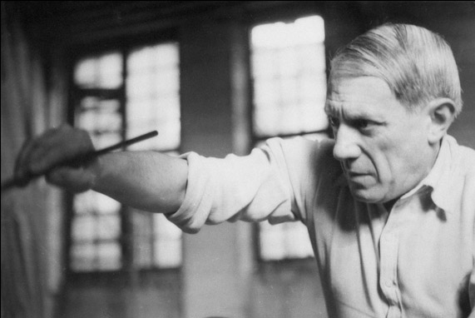

"Every child is an artist. The problem is how to remain an artist once he grows up."

Pablo Picasso – Self-portrait

Pablo Picasso - Photo

“3 Musicians”

Nombre Fecha Clase
Pablo Picasso—Preguntas
Read the article, look at the pictures, and answer these questions. Answer in complete sentences! 2 pts each question; 8 pts in all.

- Who taught Picasso to paint first? When did he start painting?

- What other artistic things did Picasso do other than painting?

- Read the quote by Picasso at the bottom of the article. (“Every child is an artist…”) What do you think this means? Do you agree? Why or why not?

- Look at Picasso’s painting, “3 musicians,” on the back of the artist. This is during his work as a cubist, which was a new style of painting at the time. What do you think of this kind of painting? Can you see the musicians and their instruments? Do you like the painting? Why or why not?

Nombre Fecha Clase
Pablo Picasso—Preguntas
Read the article, look at the pictures, and answer these questions. Answer in complete sentences! 2 pts each question; 8 pts in all.

- Who taught Picasso to paint first? When did he start painting?

- What other artistic things did Picasso do other than painting?

- Read the quote by Picasso at the bottom of the article. (“Every child is an artist…”) What do you think this means? Do you agree? Why or why not?

- Look at Picasso’s painting, “3 musicians,” on the back of the artist. This is during his work as a cubist, which was a new style of painting at the time. What do you think of this kind of painting? Can you see the musicians and their instruments? Do you like the painting? Why or why not?

